Juris is open but it does the window doesn’t display

Sometimes Juris hides. To get it to appear again, hover over the scales, a window of what you should see will pop up:
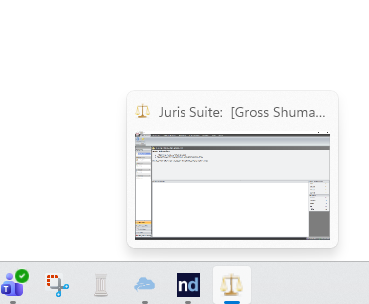

Right click where it says Juris Suite:

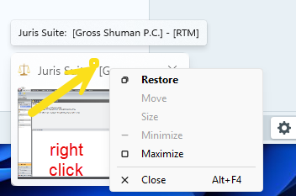
Choose MAXIMIZE. It should make the screen bigger.

4930-0546-7312, v. 1

